**DATA ANALYSIS REPORT**

**What are the busiest days and times for us?**

**Busiest Days:**

This analysis reveals that **weekends** have the greatest sales. Here, **Fridays** and **Saturdays** depict the busiest days since orders are close to **3,200**, while during **weekdays**, the volume goes a bit low. Such examples can be seen with **Mondays** and **Sundays** where the number of orders is around **2,600-2,800.**

**Busiest Hours:**

More active hours are **evenings,** typical of the pizza business since dinner hours have more orders. This trend persists throughout the year, that is, for all days of the week, so it is a peak hour in the evenings throughout the year.

**How many pizzas are we making in peak hours?**

With **49,574 pizzas** sold throughout the year, this results in a daily average of about **136 pizzas per day**. However, sales volume picks up during the peak periods, especially during Fridays and Saturdays.

- On these peak days, the total orders stand at as high as about **3,200 to 3,500**. Assuming an average number of pizzas per order to be around **2.32**, the total pizzas produced on peak days can be as high as **7,400 pizzas** on just one weekend.

-

On these days, staff and resources must also be adjusted according to the peak for these timings, since the highest activity is recorded during evenings.

**What are our best and worst-selling pizzas?**

**Best-Selling Pizzas:**

- By **Revenue**: The **Thai Chicken Pizza** is the biggest earner in terms of total revenue generated throughout the year. This is a good indication of the product's popularity and its higher price point compared with other pizzas.

- By **Quantity**: **The Classic Deluxe Pizza** was the pizza that sold in the highest quantity with more orders and sold more units. This suggests that it is one of the favourite pizzas for a very significant number of the customer base.

**Worst-Selling Pizzas:**

- By **Revenue**: The **Brie Carre Pizza** had the smallest revenue. This means that it's probably not as in demand or sold cheaper compared to the other pizzas.

- By **Quantity**: In like manner, the **Brie Carre Pizza** sold the fewest number of units, indicating low demand and poor overall performance relative to the other pizzas featured on the menu.

**Top 5 Pizzas by Revenue:**

**- Thai Chicken Pizza**

**- Barbecue Pizza**

**- California Pizza**

**- Classic Deluxe Pizza**

**- Spicy Italian Pizza**

**Bottom 5 Pizzas by Revenue:**

**- Spinach Pesto Pizza**

**- Mediterranean Pizza**

**- Spinach Supreme Pizza**

**- Green Garden Pizza**

**- Brie Carre Pizza**

**What's our average order value**

- Calculated AOV stands at **$38.31**. This average reflects the average amount customers are willing to spend for a transaction; this can, therefore, guide some pricing decisions, promotional offers, and bundle offers. For instance, if an average order is $38, it means an AOV of that, hence you would structure a meal deal or a discount threshold around that to spend above that.

With an average of **2.32 pizzas per order**, the statistics would suggest most shoppers are buying for a group as opposed to consumption, consistent with peak evening and weekend periods.

**How effective is seating capacity utilisation?**

- You have **15 tables** seating for a total of **60 chairs**. Given the year-round daily trends on total orders, not to mention the weekend bump, your seating space probably gets pretty fully utilised, especially in the evening.

- **Seating Utilisation Estimate**: On weekends (Friday and Saturday), this would translate to over **3,200 orders per day**, most of which would be dine-ins. Seating would then have to change multiple times in a single day. With an aggressively conservative estimate of being only 30% dine-in, it would equate to **960 orders** spread over 15 tables. Over **60 orders** would be spread across each table during such busy periods, thus meaning extremely high utilisation.

-On quieter weekdays, with orders around **2,600 to 3,000**, the pressure on seating would be lower, perhaps making service easier. During peak periods (e.g., evenings, weekends), the seating is probably at or close to capacity. Optimising your menu to include quicker prep items or placing promotions in off-peak time slots could help improve seating turnover and more customers during busy periods.

**Summary of Key Insights:**

- **Days for Sales:** **Fridays** and **Saturdays**, especially in the evenings.

- **Order Volume:** Which is currently at **3,200-3,500** orders at the weekends with **2.32 pizzas per order**.

- **Best-Selling Pizza**: **Thai Chicken Pizza** in **revenues** and **Classic Deluxe Pizza** by **quantity**

- **Worst-Selling Pizza**: **Brie Carre** both in quantity and revenues

- **Average Order Value**: $**38.31**, which implies that customers spend a lot at each visit.

- **Seating Utilisation**: This is high during peak hours and is likely to stretch the maximum capacity during weekends' evenings.

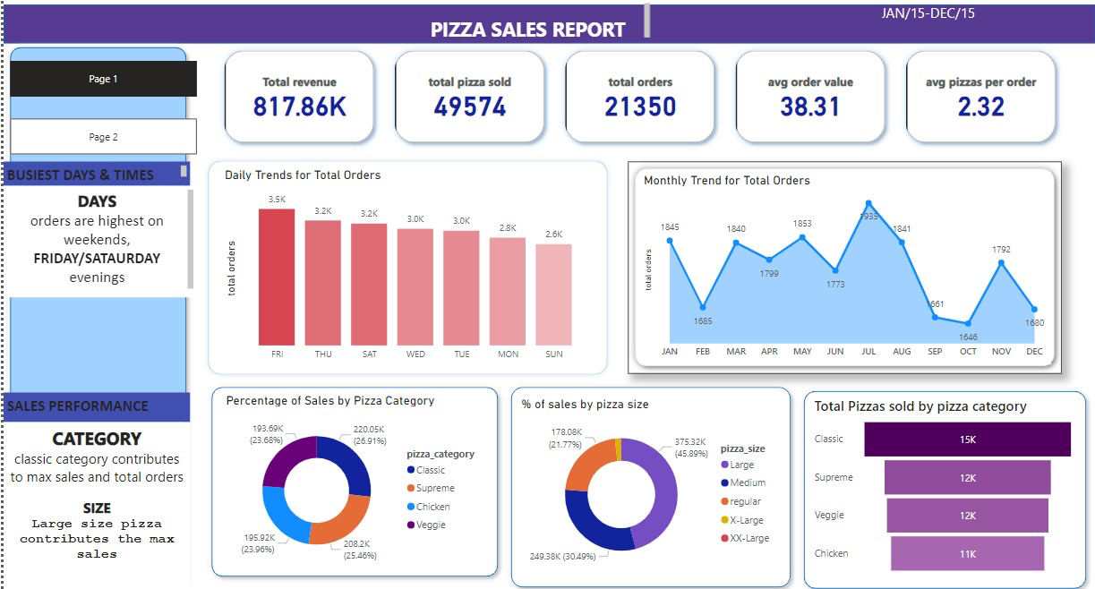

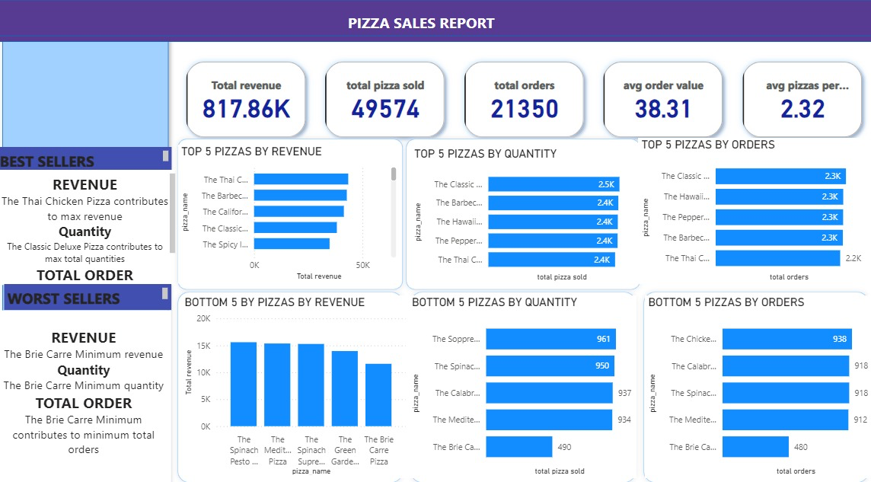

**~ By**

**U. Hara Sreeka**